U683CL
User Manual

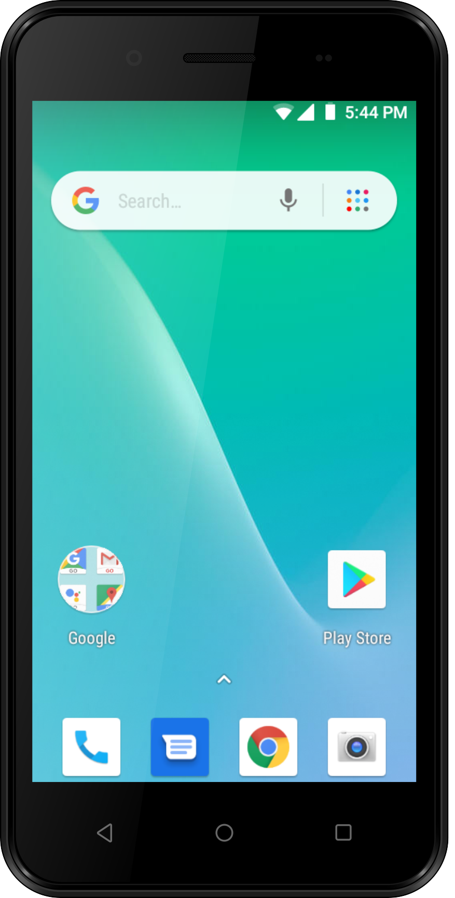

Conventions used in this guide

In this user guide, we use the following symbols to indicate useful and important information:

NOTE
Notes, usage tips, or additional information

Warning Situations that could cause injury to yourself or others
Caution Situations that could cause
damage to your device or
other equipment

Specifications 3
Basics 4
In Box 4
Phone Overview 4
Battery 4
Turning Phone On or Off 5
Touchscreen Gestures 6
Using the Onscreen Keyboard 7
Editing Text 8
Getting Started 9
GoogleTM Account 9
Getting to Know the Home Screen 10
Customizing the Home Screen 10
Essential Display Icons 11
Notifications Panel 12
Opening & Switching Between Applications 12
Sleep Mode 13
Adjusting Volume 14
Searching Your Phone and the Web 14
Connecting Your Phone to a Computer 15
Phone Calls 16
Making Calls 16
Answering or Rejecting Calls 17
Using In-Call Options 18
Using Call Log 18
Listening to Your Voicemail 19
Using Voice Dialer 20
Contacts 21
About contacts 21
Opening Your contacts 21
Getting Started 21
Editing/Deleting Contacts 23
Communicating 24
Account Setting 24
Messaging 25
About Messaging 25
Sending Messages 25
Reading Messages 26
Receiving Emergency Alerts Messages 27
Changing Messaging Settings 28
Google Go 29
Gmail 29
Maps Go 30
Calendar 31
Google Play Store 34
Web 36
Chrome 36
YouTube Go 38
Wi-Fi 40
Bluetooth 41
Using Bluetooth 41
Disconnecting or Un-pairing from a Bluetooth Device 42
Connecting to a Bluetooth Headset 42
Sending and Receiving Information Using Bluetooth 42
Entertainment 44
Camera/Camcorder 44
Sound Recorder 45
Tools 46
Clock 46
Calculator 47
Settings 48
Settings on Your Phone 48
System update 51
Safety and use 52
Please read before proceeding 52
Limitation of damages 52
Important health information and safety precautions 53
Regulatory agency identifications 59
HEARING AID COMPATIBILITY HAC FOR WIRELESS TELECOMMUNICATIONS DEVICES 60

Specifications

- Display

• 5.0 inch FWVGA(854×480) Display
• Capacitive Touch Screen

- Camera

• Front camera:0.3MP
• Rear camera: 2.0MP

- Dimensions and Weight

• Dimensions: 146.9*73*9.6mm

- Memory
• 8GB (ROM)/1GB (RAM)
• External memory : Supports up to 64GB

- Operating System

• AndroidTM 8.1 Go

- Connectivity

• WIFI(802.11 b/g/n), Bluetooth4.1

- Sensors

• Accelerometer, Proximity sensor, Geomagnetic sensor

- Power Management (Performance)

Battery Type | Capacity | Standby Time | Talk Time
Lithium-Ion(Li-ion) | 2000mAh | Up to 116 Hours (4.83Days) | Up to 309minutes

Basics

In Box
The U683CL comes with the following items included in the
box:

1. Mobile phone
2. Micro USB cable
3. Battery cover
4. Battery
5. USB power adapter
6 .QSG

Phone Overview

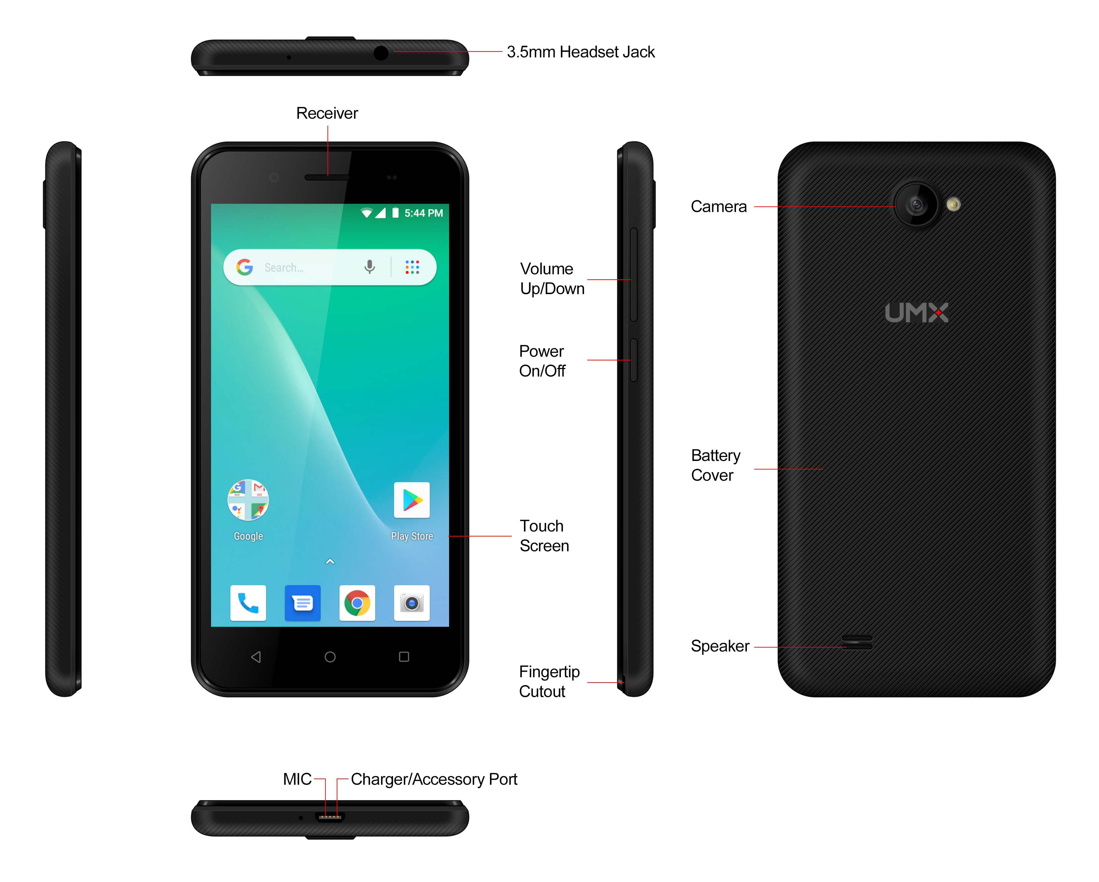

Battery
Note that browsing the web frequently, extended data usage, being in a poor signal area, or subjecting the device to extreme temperatures will cause the battery to discharge quicker than normal. To increase battery life, limit your data usage, or turn off GPS and Bluetooth when not required.
Charging your battery

Before you turn on your device and start using it, it is recommended that you charge the battery.
1. Plug the USB cable into the USB power adapter.
2. Plug the power adapter into a standard outlet.
3. Locate the USB port located on the underneath of your device.
4. Plug the other end of the USB cable into the phone’s micro USB port.
5. The USB icon on the cable should always face up when connecting the cable to your device as shown.

NOTE
• It is more efficient to charge the battery with your device powered
off.
• Battery operating time gradually decreases over time.

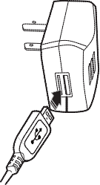
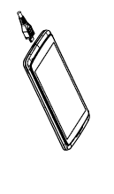
MicroSD Card
Use the microSD card to store your photos, videos, music and certain apps from Google PlayTM Store. You can also move and copy files to your computer from your device.

NOTE When you insert or remove the microSD card, you should remove the battery cover.

1. Insert the microSD card
1. Locate the microSD card slot and remove the cover.

Insert the microSD card into the slot with its
gold contacts facing right above battery until it clicks
into place.
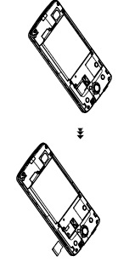

2. Removing the microSD card

1. Remove the microSD card cover.

2. Press the microSD card to eject it from the slot then slide it out the rest of the way.

- Removing the microSD card while
the phone is on

If you need to remove the microSD card while the phone is on, unmount the microSD card first to prevent corrupting or damaging the files in the microSD card.
1. From the Home screen, tap Apps > Settings.
2. Tap Storage >Unmount SD card >OK.
3. Remove the microSD card by following the steps in “Removing the microSD card”.

Turning Phone On or Off

1. Turning your phone on
1. Press and hold Power/Lock key.

NOTE The first time you use your phone you’ll need to set it up. See the Getting Started chapter for details.

2. Turning your phone off

1. If the display is off, press Power/Lock to turn it back on.
2. Press and hold Power/Lock for a few seconds.
3. When Phone options menu appears, tap Power off >OK.

Touchscreen Gestures
Tap | To select onscreen items such as application and settings icons or press onscreen buttons, simply touch them with your finger.
Tap and hold | To open available options for the item, simply touch and hold your finger on the screen over the item.
Swipe or slide | Quickly drag your finger vertically or horizontally across the screen.
Drag | Tap and hold your finger before you start to drag. While dragging, do not release your finger until the item reaches your desired location.
Flick | Flicking the screen is similar to swiping, but you only need to swipe your finger in lighter and quicker strokes. This finger gesture is always in a vertical direction, such as flicking through the contacts or the message lists.
Rotate | For most screens, you can automatically change the screen orientation from portrait to landscape by turning the phone sideways. When entering text, you can turn the phone sideways to bring up a bigger on-screen keyboard.

Using the Onscreen Keyboard
You can enter text using the onscreen keyboard. Some applications open the keyboard automatically. In others, tap anywhere in a text field to open the keyboard.

1. Tap each letter on the on-screen keypad.
2. Tap and hold a letter for additional key options (not all keys have additional options). Additional key options include numbers and letters with accent marks. If options are available, you will see a box with all the options shown. Slide your finger to select the character you want.
3. Continue until you have finished the word.

You can also use the following icons:

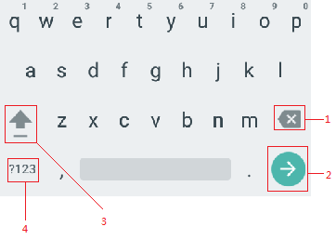

•Tap 3 while you type. When you release the key,
the lowercase letters reappear.
•Turn caps lock on. double-tap or touch & hold
•Tap 3, so it changes to . Touch shift key again
to return to lowercase.
• Tap 1 you can to delete words, tap 4 you can change to the number and sign keyboard.
• To hide the Android keyboard, press Back .
• When you write a new message, you can tap 2 to skip from the receiver frame to text frame.

NOTE When you type the notification panel will have a “select input method” you can set the input methods.

Adding, Editing or Deleting Words in the User Dictionary
Sometimes you may need to add a word to the predictive text dictionary, for example, a name or a specialized technical word. If you want to add a word to your User dictionary while entering text, double tap the word to highlight it, then tap and hold the word and select Add ** to dictionary.

Adding a word manually
1. From the Home screen, tap Apps >Settings.
2. System > Language & input >Personal dictionary.
3. Press Add.
4. Type the word >tap OK.

Editing or deleting a word
1. From the Home screen, tap Apps > Settings.
2. System > Language & input >Personal dictionary.

• To edit words from the dictionary, tap the word you want to edit >Edit > Edit the word > Tap OK.

• To delete words from the dictionary, tap the word you want to delete >Delete.

Editing Text
You can select, copy or cut the text you’ve entered, then paste it in another text field within the user interface.

NOTE Some applications may offer different text editing methods.

1. Selecting text
1. Tap the text field.
2. Move the cursor to the beginning or end of the desired text by tapping in the location you want the cursor.
3. Tap and hold the text field.
4. Tap Select word in the pop-up menu.

• Or tap Select all to select all the text in the text field.

5. Drag your finger to move the text cursor to a letter within the text that you want to select. The selected text is highlighted in orange.

2. Cutting and copying the text
1. Double-click to select the text to cut or copy it.
2. Tap and hold the selected text.
3. Tap Cut or Copy in the menu that opens.

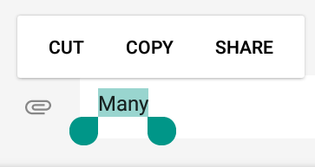

• If you tap Cut, the selected text is removed
from the text field. In this case, the text is saved to
the clipboard, so that you can paste it into another
text field.

3. Pasting the text
1. Cut or copy the text to paste.
2. Tap the text field where you want to paste the text and move the cursor to your desired location.

• You can paste text that you copied from one application into the text field in any other application.
3. Tap and hold then select Paste in the pop up menu.

• The text is inserted after the cursor. The text also remains in the clipboard, so you can paste that same text into another location.

Getting Started

Google Account

You must sign in to a Google account to use Gmail, Google Calendar, and other Google applications; to download applications from Google Play Store; to back up your settings to Google servers; and to take advantage of other Google services on your phone.

1. Registering a Google account

Gmail, Google Play Store, and other applications require a valid Google account for use. You will be prompted to login into Google the first time you use these applications.

1. Tap Existing>Sign in to register your Google account.
• If you don’t have a Google account, tap New instead. See the next section for more details.
2. Enter your Google account Email and Password > Tap Sign in.

2. Creating a new Google account

1. Tap New > Enter First name, Last name and Email > Tap Next.
2. Enter a password in to the Type a password, Confirm password fields, then tap Next.
• Password tip: Your password must be a minimum
of 8 characters in length.

3. Select Security question and enter the Answer, which will be needed if you forget your password and then enter a Secondary Email >Create.
4. Read through Google Terms of Service > Tap I agree, Next.
5. Enter the letters shown on the screen > Tap Next > Tap Finish.

3. Adding a Google account
1. From the Home screen, tap Apps > Settings.
2. Users & accounts > Accounts > Add account.
3. Tap Google > Tap Existing.
4. Tap Sign in to register your Google account.
5. Enter your Google account Email and Password > Tap Sign in >Finish.
• The U683CL supports multiple Google accounts.
• If you have the same contact across multiple Google accounts, you can merge duplicates into a single
item in the contact list.

Getting to Know the Home Screen

1. The Home screen is displayed when the device is in idle mode. You can add your favorite apps, shortcuts, folders and widgets to the Home screen so they’re only a tap away.

2. Press Home to return to the center home screen.

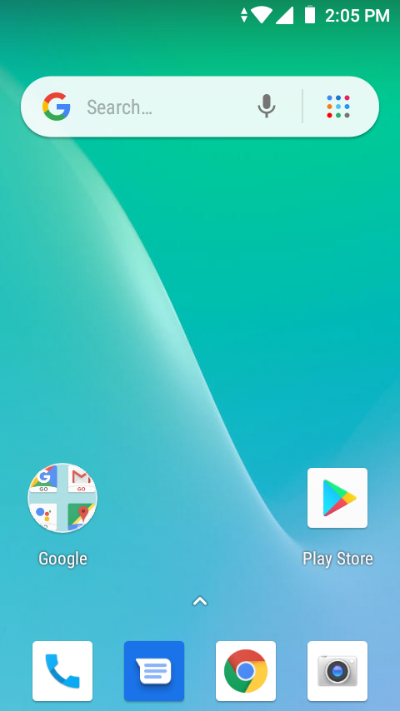

1. Previewing the Home screens

1. From any Home screen, tap and hold an application.
2. When you choose a desired Home screen, the application shifts to the selected Home screen.

Customizing the Home Screen

The Home screens and display wallpaper are customizable.

- Home screen customization options

Open the Home screen you want to customize.

2. Moving an item on the Home screen

1. From the Home screen, tap and hold the item you want to move until it vibrates. Don’t lift your finger.
2. Drag the item to a new location on the Home screen.
3. Lift your finger at the location where you want the item.

To add a shortcut for any application to a Home screen, tap Apps, tap and hold the item, then drag it onto a Home screen.

3. Removing an item from the Home screen

1. From the Home screen, tap and hold an item until it vibrates. Don’t lift your finger. The × Remove icon will appear at the top of the display.
2. Drag the item to × Remove.
3. When the item turns blue, lift your finger.

4. Changing the Wallpaper of the Home screen

1. From the Home screen, tap and hold any empty area on a Home screen long time.
2. Tap WALLPAPERS:
From the list of menus, Choose a photo from your camera gallery or memory card storage.
3. Tap Set wallpaper.

Essential Display Icons

1. Status icons

You can tell a lot about your phone when you understand the icons in the Status bar. Here’s what each one means:

 | Signal strength |  | Synchronized with the web
 | No signal |  | Vibrate only mode
 | 3G network connected |  | Speakerphone is on
 | Wi-Fi signal strength |  | Silent mode-no audio or vibration
 | Airplane mode |  | Microphone is muted
 | Data synchronizing |  | It indicates that battery is remaining  (Empty to full charge states)
 | Bluetooth is on |  | Connected to a computer via USB cable
 | Storage is insufficient

2. Notification icons

Notification icons in the Status bar alert you to items that may require your attention such as new messages, calendar event reminders, missed call notifications, etc. Here’s what each one means:

 | Call in progress |  | Downloading data
 | Missed call |  | Uploading data (animated)
 | Call Diverted |  | General Warning Icon
 | More (not displayed) notifications |  | No microSD card installed
 | New Google Talk instant message |  | MicroSD card is being prepared
 | New voicemail |  | Upcoming event
 | New message |  | Alarm is set
 | New Gmail |  | Wi-Fi is on and wireless networks are available
 | Connected to or disconnected from VPN |  | Song is playing
 | New Email

Notifications Panel

When you receive a new notification, an icon will be displayed in your status bar at the top of your screen.

1. Viewing and responding to Notifications
1. Tap and hold Status bar, and then slide your finger downward to open the Notifications panel.

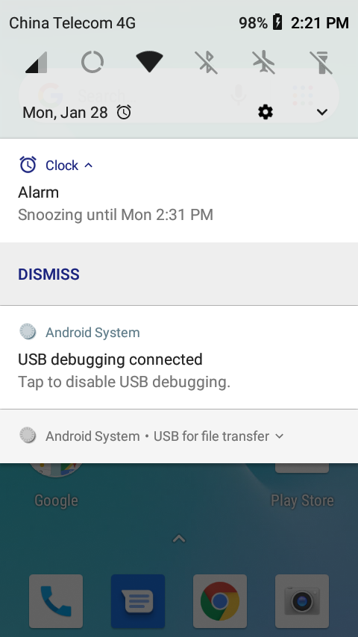

2. If you have multiple notifications, you may need to scroll to see them all.
3. Tap a notification to respond to it.

2. Closing the Notifications panel

Drag the bottom bar of the panel up. Or just press Back.

Opening & Switching Between Applications

1. Opening and closing the Applications List

1. From the Home screen, tap Apps.
2. To close, press Home or Back.

2. Switching to a recently used application
1. From any screen, tap Recent apps. Scroll to see all recently used application.

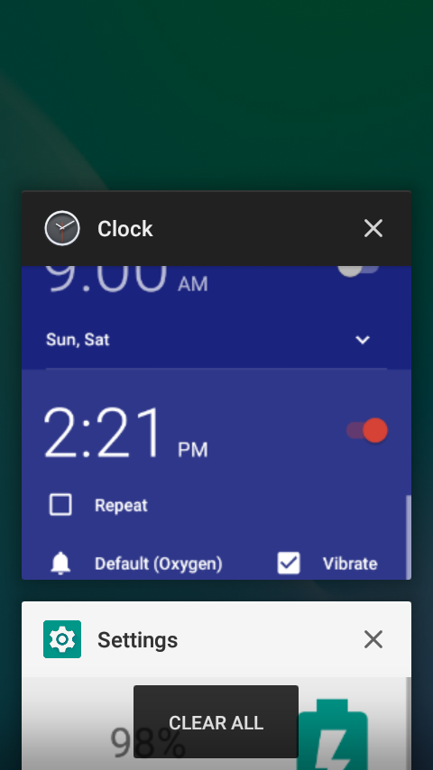

2. Tap an icon to open the application or press Back
to return to your previous screen.

Sleep Mode

Sleep mode saves battery power by turning off your display. You will still receive messages and calls when the display is turned off.

1. Switching to Sleep mode

Your phone automatically turns off the display after a period of inactivity. To customize the screen timeout settings, from the Home screen, tap Apps > Settings > Display >Sleep.

2. Waking up from Sleep mode

1.Your phone automatically wakes up when you have an incoming call.
2. To wake it up manually, press Power/Lock. You’ll need to unlock the screen as described below.

3. Unlocking the screen

On the lock screen, tap the unlock icon and slide your finger in the direction of the arrows to unlock the screen. The screen unlocks automatically when you answer an incoming call.

NOTE If you have set up a screen unlock pattern, pin, or password, you will be asked to draw the pattern on the screen or enter the PIN or password to access the phone software.

4. Activating Secure Screen Lock

1. From the Home screen, tap Apps > Settings.
2. Tap security&location >screen lock.
• If you have already configured the screen lock, tap screen lock to change how to lock or unlock your screen.
3. Tap Pattern, PIN, Password, or Face Unlock. Then enter a custom pattern, PIN or password as prompted.

• If you select ‘None’, screen unlock security is cancelled.

Adjusting Volume
Ringtone and Media volume are independent of each other and adjusted separately.

1. Adjusting the ringer volume

From the Home screen, press Volume up or Volume down on the right side of the phone to
adjust the ringer volume to your desired level.

• While in the lowest ringer volume level, press Volume up or Volume down once to set your phone to Vibrate mode. To set your phone to Silent mode, you can press Volume down once again.
• While in the Silent mode or Vibrate mode, press Volume up once to switch to ringtone mode.

2. Adjusting the media volume

While playing music, watching a video or using preloaded or downloaded games or applications, press Volume up orVolume down on the right side of the phone to adjust the media volume.

3. Adjusting the earpiece volume for phone calls

During a phone call, press Volume up or Volume down.

4. Adjusting the volume via Settings menu
1. From the Home screen, tap Apps > Settings.

- Tap Sound > Volumes.

- Drag the volume sliders left or right to adjust your phone’s Ringtone, Media, and Alarm. Your phone plays a sample tone at the selected volume level while you drag the slider.
- When you’re done, tap Back or Home.

Searching Your Phone and the Web

The search key is a powerful part of the UL40’s software and enables you to quickly locate files, contacts, and applications. You can also search the web using your favorite web search service.
1. Tap Apps > Google Go.
2. Begin entering text, or tap a previously used search term.
• As you enter the text, matching items on your phone and suggestions from Google web search will appear on the screen.
3. Tap a suggestion to go directly to that result.

Connecting Your Phone to a Computer

1. Copying files to/from the microSD card

You can copy your music, photos, and other files to
the microSD card of your phone.

NOTE This option is available only when a microSD card is inserted into the slot of your phone. While your phone is connected to a computer, USB Mass storage mode prevents you from using applications that access the memory card.

1. Connect your phone to your computer using the supplied USB cable.
2. Open the Notifications panel >tap USB options.
3. On your computer, the connected phone is recognized as a removable hard drive.
4. Navigate to the removable drive and open it.
5. Do one of the following:

• Copy the files from the computer to the microSD card’s root folder.

• Copy the files from the phone’s microSD card to a folder in your computer.

6. After copying the files, un-mount the removable drive (that is, your phone) as required by your computer’s operating system to safely remove your phone.

7. After you have un-mounted the removable drive, you can disconnect the phone from the computer.

Phone Calls

Making Calls
The simplest way to make a call is to dial the number directly. You can also call numbers listed in your call log or Contacts list.

1. Making a call from the dialer screen
1. From the Home screen, tap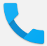 Phone. Or tap Apps > Phone.
2. Tap the number you want to dial.
• If you make a mistake, tap to erase a single character. Tap and hold to erase the entire string.
3. Tap Dial.
• The Calling screen is shown and appears in the Status bar while the call is active.
• To change the volume during a call, press Volume up / Volume down.
4. To end the call, tap End Call.

2. Entering a Pause/Wait
Pause and wait options can help you dial additional numbers such as a voicemail password, or phone banking system menus.
1. From the Home screen, tap Phone.

2. Tap the number you wish to dial > tap Option >Add 2-sec pause or Add wait.

• Add 2-sec pause: Your phone will wait for 2 seconds then continue to dial the remaining numbers automatically.

• Add wait: Your phone will wait with the message, ‘Send the following tone?’ until Send is tapped, then continue dialing the remaining numbers.

3. Making an international call
1. From the Home screen, tap Phone.
2. Tap and hold 0 until the international prefix ‘+’ appears.
3. Tap the country code, area code, and phone number.
4. Tap Dial.

4. Calling a number from the Call log
Your phone logs all incoming and outgoing calls.
1. From the Home screen, tap Phone > Call log.
2. Tap Dial at the right of any entry to dial.

• Calls are listed with the most recent at the top.

• Calls to the same phone number are grouped together.

• Scroll up or down to view additional entries in the log.
• If you want to edit a number before calling, tap
and hold the desired number, and then tap Menu
>Edit number before call.

5. Making a call from the Contact list
1. From the Home screen, tap Phone > . Or tap Apps > People.
2. Scroll through the contact list.
• To find a specific contact, you can search by tapping Search. Enter the name of the contact you’re searching for. As you type, contacts with matching names appear below the search box. Or you can use the tab on the right hand side of the screen to scroll through the alphabetical contacts.
3. Tap the contact you want to call.
4. Tap the phone or mobile number.

6. Making an emergency call
Your phone supports international emergency numbers such as 911. Emergency calling is supported anywhere the phone has a network signal.
1. Making an emergency call
1. From the Home screen, tap Phone.
2. Tap the emergency number for your location.
This is usually 911, *911 or #911.
3. Tap Dial.
4. To end the emergency call, tap End Call.

2. Making an emergency call while the phone is locked
1. When your phone is no service status, Emergency call button is displayed on the lock screen. Tap Emergency call.
2. Tap the emergency number for your location. This is usually 911, *911 or #911.
3. Tap Dial.
4. To end the emergency call, tap End Call.

Answering or Rejecting Calls
When you receive a phone call, the screen displays the caller’s name, phone number, and caller ID icon (if stored in Contacts). When you receive a phone call from a phone number not stored in your Contacts, only the default caller ID icon and phone number are shown.

All incoming calls are recorded in the Call log. If you miss a call, you receive a reminder notification.

1. Answering or rejecting an incoming call

- Drag the icon in the direction of the arrows
to answer the call.

• If you were already in a call, the first call is placed on hold during answering the new call.

• To silence the ringer before answering the call, press either of the volume keys.

NOTE The caller you reject is sent directly to your voicemail box to leave a message.

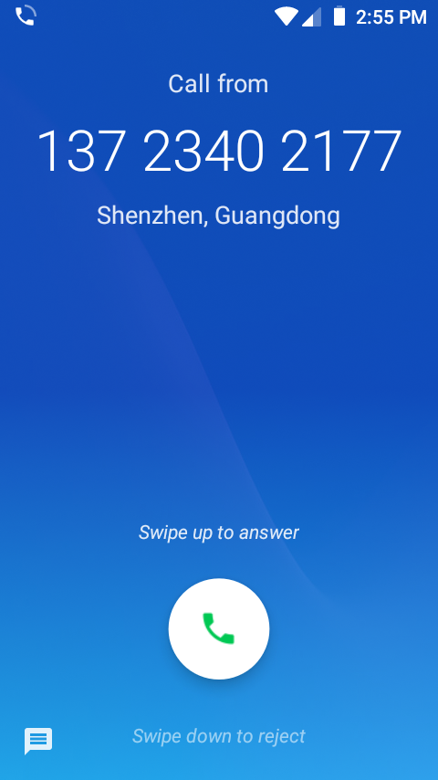

2. Checking missed calls
• If you miss a call, is displayed in the Status bar.
• If you open the Notifications panel, you will see the number of missed calls. Tap the notification to be taken to the call log and view detailed information.

Using In-Call Options
When a call is in progress, the following options are available:

Dial Pad | Tap Dial Pad to enter additional numbers during your call.
Mute | You can unmute the microphone by tapping Mute icon again.
Audio | You can turn the speakerphone off by tapping the Speaker icon again.  The speaker is turned off automatically when your current call ends.
Bluetooth | When a Bluetooth device is paired and connected to your phone, you can conduct all calls using Bluetooth for hands-free conversation. When using Bluetooth headset during a call, the current call screen has a blue border and the Ongoing Call icon turns blue in the Status bar.  Tap Bluetooth icon to toggle in-call audio to and from the Bluetooth accessory.

NOTE To avoid damaging your hearing, do not hold the phone up to your ear when the speakerphone is on.

Using Call Log
The phone stores the numbers of all incoming and outgoing calls in the Call log. The Call log displays the details of the call including time, date, and duration.

1. Opening the Call log
1. From the Home screen, tap Phone > Call log.
• Calls are listed with the most recent at the top. Calls of the same phone number are grouped together. Scroll to view earlier entries in the log.

NOTE You can tap and hold the desired number in the call log
list to select options such as Call, View contact, Edit
number before call, Send a message, Add to contacts, Call details, Copy number, Block number.

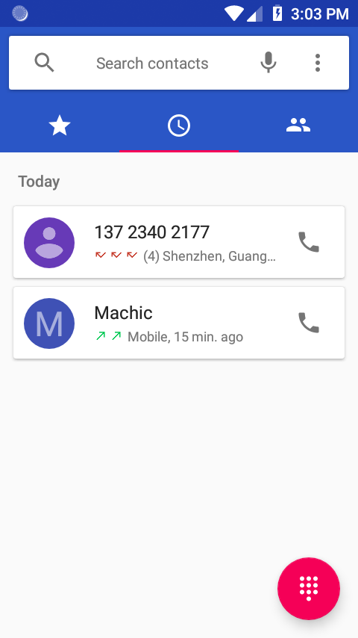

2. Calling a number from the Call log
1. From the Home screen, tap Phone > Call log.

- If you want to call a number directly ,tap at the right of the entry. Or select a contact > tap Dial

• If you want to edit a number before calling, tap
and hold the desired entry, and then tap Option >Edit number before call.

3. Adding a phone number from your Call log to your Contacts list
1. From the Home screen, tap Phone > Call log.
2. Tap the desired entry >Add to contacts.
3. In the list of contacts that opens, tap Create new contact or add to an existing contact.
4. Tap Done.

4. Sending a text message from the Call log
1. From the Home screen, tap Phone > Call log.
2. Tap the contact > Send text message.
3. Enter your message and tap to Send.

5. Clearing the Call log
1. From the Home screen, tap Phone > Call log.
2. Tap Option >Call log>Tap >Clear call log >OK.

• To remove just one entry from the Call log, tap the entry. In the pop up options, tap Call details >click Delete icon>OK.

Listening to Your Voicemail

Voicemail application is displayed only when phone calls are available. When you have a new voicemail message, appears in the Status bar.

1. Calling your voicemail from the Dial Pad
1. From the Home screen, tap Phone.
2. Tap your phone number and tapDial.

2 Calling your voicemail from the Notification panel
1. Open the Notifications panel and tap ” New voicemail”.

Using Voice Dialer

You can use the Voice Search application or Voice Dialer application to place a phone call by speaking the name of a contact or a phone number.

1. From the Home screen, tap Phone > Search contacts.

• If you have a Bluetooth headset that supports “voice-recognition” or “voice-dialing,” you may be able to open Voice Search by pressing and holding your headset’s main button and dial by voice using your headset. For details, see your headset manual.
2. Say the name of the contact you want to call

• Or, follow one of the suggestions for dialing a number or controlling your phone in other ways.

Contacts

About contacts
Contacts give you quick and easy access to the people you want to reach. Contacts from Google accounts are also downloaded and synced with the Contact list.

You can manage your communications with your contacts via phone, messaging, and email without the need to jump from one app to another.

Opening Your contacts
Open contacts to add, view, and communicate with
your friends and acquaintances.
1. From the Home screen, tap Apps > contacts.

• All of your contacts are displayed alphabetically in a scrolling list.

• You can use the tab on the right hand side of
the screen, or flick your finger up or down to
scroll quickly.

Getting Started
1. Adding a new contact
1. From the Home screen, tap Apps > contacts.
2. Tap ALL > .
3. If you have more than one account, select an account then enter the information for the contact.

• Tap > select Take photo or Choose photo from Gallery to add a picture.

• Enter your contact’s information.
4. Tap Done.

Saving a phone number from the Dial Pad
1. From the Home screen, tap Phone.
2. Enter the number >Tap Create new contact.
3. Enter the information for the contact>tap Done.

Storing a contact using Call log
1. From the Home screen, tap Apps > Phone.
2. Tap Call log >tap the number you want to save > Add to contacts.
3. Tap Create new contact or select an existing contact.
4. If you have more than one account, tap the account where you want to save the contact > enter the information for the contact > tap Done

2. Importing / Exporting / Sharing contacts
Importing contacts from your microSD card
If you have contacts stored in vCard format on the microSD card, you can import them into Contacts on your phone.
1. From the Home screen, tap Apps > contacts.
2. Tap Option >Import/Export.
3. Tap Import from .vcf file.
4. If you have more than one account on your phone, select the desired account.
5. Tap the vCard files on the microSD card. The contacts are imported.

Exporting contacts to your microSD card
1. From the Home screen, tap Apps > contacts.
2. Tap Option >Import/Export.
3. Tap Export to .vcf file.
4. Select contacts, tap OK to confirm.

• This process creates a file containing all your selected contacts with a .vcf extension on your microSD card.

Sharing visible contacts
1. From the Home screen, tap Apps >contacts.
2. Tap Option >Import/Export.
3. Tap Share all contacts > Select Bluetooth,Gmail.

3. Viewing details about a contact
1. From the Home screen, tap Apps >contacts.
2. Tap the contact whose details you want to view.
3. Tap the communication icon to start dialing, texting, or emailing the contact.
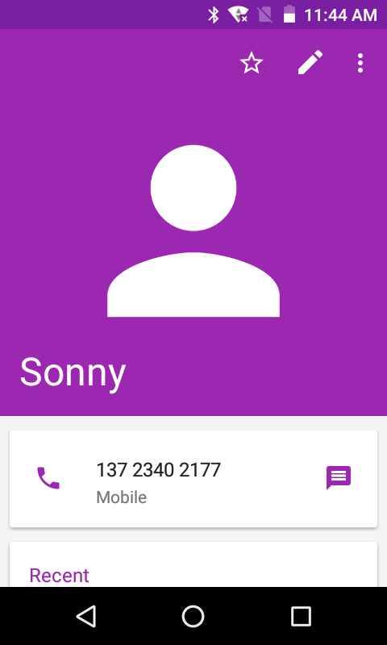
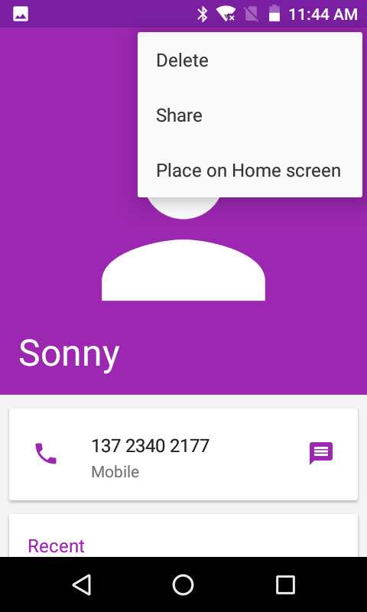

4. Search for a contact
1. From the Home screen, tap Apps > contacts.
2. Tap Search.
3. Start entering the contact’s name.
As you type, contacts with matching names appear below the search box.
4. Tap the matching contact in the list to open

Editing/Deleting Contacts
1. Editing contact details
1. From the Home screen, tap Apps > contacts.
2. Tap the contact you want to edit >Tap Edit contact.
3. Edit the contact information.
4. Tap Done.

2. Setting a contact’s default phone number/email
Setting a contact’s default phone number
The default phone number is used when you initiate a call or text message by tapping and holding a contact.
1. From the Home screen, tap Apps > contacts.
2. Find the desired contact > Tap and hold the phone number to designate it as the default phone number.
3. Tap Set default.

• The default phone number is indicated with a checkmark.

Setting a contact’s default email
The default email is used when you send an email from the list by tapping and holding a contact.
1. From the Home screen, tap Apps > contacts.
2. Find the desired contact > Tap and hold the email address to designate it as the default email address.
3. Tap Set default.

• The default email is indicated with a checkmark.

3. Setting a ringtone for a contact

1. From the Home screen, tap Apps > contacts.
2. Tap the desired contact> Tap Edit contact.
3. Tap Option >Set ringtone.

• Tap a ringtone from the list to play when the contact calls. A sample of the ringtone is played.
4. Tap OK.

4. Adding a contact to your favorites
1. From the Home screen, tap Apps > contacts.
2. Tap the desired contact >Tap .
• To remove a contact from your favorites list, tapcontacts >tap the desired contact >Tap .

5. Linking contacts
1. From the Home screen, tap Apps > contacts.

2. Tap the contact you want to save. The others will merge into this file. This is the contact you will see in contacts after linking.
3. TapEdit contact > Tap Option >link.

4. Tap the contact you want to join with the first contact. The information from the second contact is added to the first contact, and the second contact is hidden.

6. Deleting a contact
1. From the Home screen, tap Apps > contacts.
2. Tap the contact you want to delete, tap Option >Delete.
3. Tap OK.

Communicating
1. Sending text message
1. From the Home screen, tap Apps > contacts.
2. Tap and hold the contact you want to send >tap .
• The Primary Phone Number is used, or you
are prompted to choose a phone number.

2. Making calls
1. From the Home screen, tap Apps > contacts.
2. Tap and hold the contact to call >tap the number.
• The Primary Phone Number is used, or you are prompted to choose a phone number.

3. Connecting by using Quick Contact
1. From the Home screen, tap Apps > contacts.
2. Tap the icon or photo next to your desired contact >tap the desired communication method.
• Only the icons relevant to your contact’s data
are displayed.
• If there are too many icons to fit on the screen, drag
to the left or right to select an icon.

Account Setting
1. Working with Google accounts
1. From the Home screen, tap Apps > contacts.
2. Tap Menu >Manage accounts.
• After registering your Google account, your online Google contacts are synchronized to your phone. Changes made online or on the phone are automatically synchronized and updated in both locations. This address book will be used throughout the user interface.
• If you register two or more accounts, you can merge address books from the multiple accounts into one address book.

2. Contact List Display and SettingsOptions
1. From the Home screen, tap Apps > contacts.
2. Tap Option >Contacts to display.
• All contacts display in the contacts list.
3. Tap Option >Settings.
• Sort list by: Select First name or Last name.
• View contact names as: Select First name first or Last name first.
• About Contacts: Build version, Open source licenses, Privacy policy, Terms of service.

Messaging

About Messaging
Use Messaging to send text messages (SMS) and multimedia messages (MMS) to other mobile phones and email addresses.
1. From the Home screen, tap Apps > Messaging.

On the Messaging screen, your sent and received messages are neatly grouped into conversations, by contact names or phone number. You can:

• Scroll up or down the list of conversations by flicking your finger on the screen.
• Tap a contact name or number to view the conversation history.
• Tap the photo or to open additional menu options.

Sending Messages
- Sending a Text Message

NOTE Depending on your billing plan, if you exceed the single
text message character limit, you will be billed for multiple messages.

1. From the Home screen, tap Apps > Messaging.
2. Tap Create New message.

3. Enter the phone number in the To field. Fill in one or more recipients. You can:
• Enter the first few letters of a contact name or phone number. Matching contacts are displayed. Continue typing or tap a name or phone number from the search results.
• Tap > Select message recipients from your contact list > Ok.
4. Tap Type message > enter your message.
• Tap Menu to see more options.

Add subject | Add subject.
Attach | Attach Media Files or a Slideshow within the message.
Send | Send the message.
Insert smiley | Insert a smiley in the message.
Discard | Delete the message in progress.
Import Temple | Some default text

5. Tap to Send.
• Tap Back to save the message as a draft.

NOTE Your text message automatically becomes a multimedia message on below condition:
• Add subject
• Attach an item

2. Sending a multimedia message (MMS)
To compose a multimedia message, start by creating a new text message. Then simply add an attachment.
1. From the Home screen, tap Apps > Messaging.
2. Tap Create New message.
3. Enter the phone number in the To field. Or select recipients from the contact list.
4. Tap Type message > enter your message. Tap to add the message template.
5. Tap Attach > choose the type of attachment.

- Pictures | Select a photo.
- Capture picture | Capture a new photo.
- Videos | Select a video.
- Capture video | Record a new video.
- Audio | Select an audio file.
- Record audio | Record a new audio file.
- Slideshow | Create a slideshow from up to 10 of your photos.

6. From the message body, tap:
• View: To view the attached item.
• Replace: To change attached files.
• Remove: To remove attached files.
7. Tap Send MMS.
• Tap Back to save it as a draft.

3. Resuming a draft message
1. From the Home screen, tap Apps > Messaging.
2. Tap the message indicated by “Draft” to resume editing.
3. When you finish editing, tap Send.

Reading Messages
1. From the Home screen, tap Apps > Messaging.
2. Tap a message thread.
3. Tap and hold an individual message to see more options.

Save to SIM card | To save the message to SIM card.
Call icon | To call the message sender
Add to Contacts | To save the phone number or email address to Contacts. (Only on messages from unkown number)
Forward | To forward a message. Enter a recipient, edit the content of the message as needed >tap Send.
Copy message text | To copy text from a message.
View message details | To view details about a message.
Delete message | To delete a message.
1. Deleting a message thread
1. From the Home screen, tap Apps > Messaging.
2. Tap and hold to select the message thread, tap
Delete thread.
• If you want delete all message threads, tap and hold a message thread and select all, tap Delete all threads.
3. Tap Delete.

2. Searching messages
1. From the Home screen, tap Apps > Messaging.
2. Tap Search to search.
3. Enter the search term >tap Search.

3. Replying to a message
1. From the Home screen, tap Apps > Messaging.
2. Tap the received message > tap Type message > enter your message.
3. Tap Send.

Receiving Emergency Alerts Messages

Emergency Alerts service allows you to receive automatic alerts in times of crisis (e.g., earthquake, hurricanes, etc.). Wireless Emergency Alerts (WEA), also known as CMAS, is a part of a national alerting system called IPAWS (Integrated Public Alert and Warning System) that enables emergency management officials to rapidly disseminate the warnings and safety information via text alerts to wireless phones based on the phones’ geographic location, The Federal Emergency Management Agency or FEMA is responsible for receiving the alerting information and forwarding the alerts to participating wireless carriers such as Sprint. Such alerts may come from the President of the United States; the National Weather Service, state or county public safety officials. This system is integrated into the same national alerting services that serve television and radio today. For more information regarding WEA/CMAS please go to: FEMA website. http://www.fema.gov/emergency/ipaws/projects.shtm#6

1. Receiving Emergency Alerts Messages
1. From the Home screen, tap Apps > Messaging.
2. Tap Emergency alerts message you want to view. Emergency alert messages are indicated with Emergency alert icon.
• If Emergency alert arrives on your phone during a call, is displayed in the Status bar. If Presidential Emergency Alert, emergency alert icon will flashes. If non-Presidential, Emergency alert icon is static icon.
• Only the Presidential Emergency Alert icon is displayed under the Time/Date on the unlock/lock screen.
• If you are on an Emergency alert message screen in the Messaging application, the following options are removed or disabled : Reply, Forward, and Call.

• If you have power cycled your phone and a Presidential Emergency Alert has not been viewed, the Presidential Emergency Alert icon will continue to flash when the device is powered on again.

Changing Messaging Settings
1. From the Home screen, tap Apps > Messaging.
2. Tap Option >Settings.

- Storage settings

Delete old messages | Check to delete older messages in a thread when messaging memory or thread limits are reached. Uncheck to keep all messages. You may need to manually delete messages if the messaging memory limit is reached.
Text message limit | Tap to set the number of messages to save per message thread. When the limit is reached, older text messages are deleted if ‘Delete old messages’ is checked.
Multimedia message  limit | Tap to set the number of multimedia messages to save per message thread. When the limit is reached, older multimedia messages are deleted if ‘Delete old messages’ is checked.

- Multimedia message (MMS) settings

Auto-retrieve | Uncheck to download only the heading of multimedia messages. You will need to tap the MMS message heading and manually download each MMS message. You may want to use this feature when roaming or when connected to a slow data network.
MMS Validity period | Set MMS Validity period to Maximum or Two days

- Notification settings

Sound | Select a ringtone to sound when you receive new message notifications.
Vibrate | Set the phone to vibrate every time you receive a new message notification, only when silent mode, or never.

- Receive Emergency Alerts

Show extreme threats | Set to receive Extreme Emergency Alerts.
Show Severe alerts | Set to receive Severe Emergency Alerts.
Show Amber alerts | Set to receive Amber Emergency Alerts.
Turn on notifications | Set to display emergency alert broadcasts
Alert reminder | Set alert reminder to once, every 2 minutes, every 15 minutes or off
Speak alert message | Set to use text-to-speech to speak emergency alert messages

Google Go

Gmail

- Opening your Inbox and Reading your Gmail

The inbox is your default Gmail view. All your received emails are delivered to your inbox.
1. From the Home screen, tap Apps > Gmail.
2. Tap the email you want to read.

• Tap to star the email.
• If the sender is a friend in Google Talk, you can
see your friend’s online status.
• Tap Delete to delete the message from your inbox.
• Slid left and right to see the previous or next message in the list.

Replying to or forwarding an email message
1. From the Home screen, tap Apps > Gmail.
2. When reading a message:

• To reply to the sender, tap .
• To reply to all message recipients, tap Reply all.
• To forward the message, tap forward.

2. Sending a new email
1. From the Home screen, tap Apps > Gmail.
2. From any message list, tap .
3. Enter a name or address in the To field. To
send the email to several recipients,
separate each email address with a comma.
4. Enter a subject in the Subject field.
5. Type the message text in the Compose Mail field.
• To attach an image file, Tap Attach file>select the picture you want to attach.
6. Tap Send.
• To save the message as a draft, tap Option >Save draft.

3. Working with Multiple Email Messages

You can archive, delete or label groups of email messages at the same time.
1. From the Home screen, tap Apps > Gmail.
2. From any message list, check the box next to the email messages you want to work with.

4. Switching between Google accounts
If you have set up two or more Google Accounts on your phone, you can switch between them in Gmail. Gmail displays only one Google Account at a time. The current account is shown at the top right of any message list.
1. From the Home screen, tap Apps > Gmail.
2. From any message list, tap Option >Settings.

3. Tap the account that you want to view. You can also tap the account name at the top of the screen to see a list of your accounts.

5. Labeling email messages

You can organize your emails by label. Gmail has preset labels. Or you can create your own labels in Gmail when viewed on a computer. (Note: Custom label colors created on the web are not supported on your phone).
Labeling an email
1. From the Home screen, tap Apps > Gmail.
2. When reading a message, tap >Change labels.
3. Select a label > tap OK.

6. Viewing emails by label
1. From the Home screen, tap Apps > Gmail.
2. From any message list, tap > Go to labels.
3. Tap a label to view matching email messages.

7. Starring/un-starring an email message

You can star an important email to make it easy to find again. Starred emails are assigned the Starred labels.
1. From the Home screen, tap Apps > Gmail.
2. From any message list:
• Tap to star a message.
• Tap to un-star a message.

Maps Go

Use Maps to find your current location and get directions. You can search for addresses, landmarks and businesses directly on a street map or satellite image.

NOTE You need an active mobile data or Wi-Fi connection to use Maps. To see your location and get directions, you must turn on location services. From the Home screen, tap Apps >Settings > Security & location > Location services. Select one or both from Use wireless networks or Use GPS satellites. Maps may not be available for all locations.

- Opening and viewing Maps
Viewing your location
1. From the Home screen, tap Apps > Maps.
2. Shows your location on the map and points north for your reference.

Using Maps
1. From the Home screen, tap Apps > Maps.
2. While viewing a map, swipe to any direction on the screen.

- Viewing location details
Viewing information for a location
1. From the Home screen, tap Apps > Maps.
2. While viewing a map, tap and hold a location, starred place, or a search result on the map.

• A balloon opens over the location, with summary information.

3. Tap the balloon to see the address or more information.

Starring or un-starring a location
Add a Star to bookmark and easily return to a map location.
1. While viewing detail information for a location,

• Tap to star the location.

• Tap to un-star the location.

Viewing a location in Street view
Street view mode provides a street-level view of the location. Street view may not be available for all areas.
1. From the Home screen, tapApps > Maps.
2. While viewing detailed information for a location, tap .

• To view surrounding areas, swipe the screen in any direction.

- Searching for a location

You can search Google Maps for specific locations, company names, or business types.
1. From the Home screen, tap Apps > Maps.
2. Tap Search.

3. Enter the search criteria. As you type, suggested matches from your contacts, the web, and previously searched items are displayed.

• Tap to search

• Tap a suggested search term.
4. The search results are displayed as markers with letter labels on the map.

• Tap markers and titles to view more information.
• Tap to show the search results as a list >tap each item to see more information.

- Viewing map layers

Initially, Google Maps opens with a street map. You can view additional map layers, such as satellite images and traffic information. You can also view custom Web created Google Maps.
1. From the Home screen, tap Apps > Maps.
2. Tap Option >Layers. A dialog opens with a list
of layers.
3. Turn layers on or off by tapping the layer name. A check mark indicates the layer is selected.

• Tap Option > Clear Map to deselect all layers.

Layers may change the map entirely or overlay additional information.Tap icons or interactive items to explore different layer types.

5. Getting directions
1. From the Home screen, tap Apps > Maps.
2. Tap 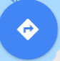> Directions.
3. Use your current location as the starting point, or enter a location in the Start point field.
4. Enter your destination in the End point field.
5. Tap or or to select your transportation method > tap Get directions.

Calendar
The Calendar application data on your phone syncs with the web-based Google Calendar service. It is also compatible with Microsoft Exchange ActiveSync Calendar.

1. Opening Calendar
1. From the Home screen, tap Apps > 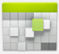 Calendar.

Events are color coded to enable you to distinguish between multiple calendars. Events times are shown using your local time zone, which is provided by your active mobile network. When traveling, you may want to set a home time zone in Calendar.

2. Creating an event

Events created on your phone will be synced to Google Calendar or Microsoft Exchange automatically.
1. From the Home screen, tap Apps > Calendar.
2. There are two ways to create an event:
• Tap Option >New event.
• In Day, Week, or Month view, tap and hold the screen at the date and/or time you want >New event.
3. Enter the name, time, location, description, and optional additional details for your event.

• If you have more than one calendar, choose the calendar to which to add the event.

• In the Guests field, enter email addresses of anyone you want to invite. Separate multiple addresses with commas (,). If your invitees use Google Calendar, they’ll receive an invitation in Calendar and by email.

• If the event occurs on a regular basis, tap the Repetition box and choose the reoccurrence information.

• You can set multiple reminders for an event.
4. Tap Done.

3. Viewing calendar and events

Changing calendar view
When you open Calendar, Month view is shown by default. You can also view the Calendar by Agenda, Day, or Week.
1. From the Home screen, tap Apps > Calendar.
2. Tap Option > Settings > General settings choose the type of view that you want

Day | Displays a chart of the events of one day,in a t able of one-hour rows,ALL-day and multiday events are displayed at the top.Each event is displayed at the corresponding time.Swipe left or right to change dates,and swipe up or down to view earlier or later times.
Week | Displays one week calendar. All-day and multiday events are displayed at the top. Swipe left or right to change weeks, and swipe up or down to view earlier or later times.

Month | Displays a chart of the events of the month. Events are shown as blue bars on each calendar date. Swipe left or right to change months.
Agenda | A list of your events in chronological order. All-day and multiday events are listed at the start of each day. Days without events are not shown. Flick up or down to view earlier or later events.
Today | Displays a chart of the events of today.
Option | You can select New event, Calendars or Settings.

Viewing event details
• In Day, Week, or Agenda view, tap an event.

• In Month view, tap a day to switch to Day view >
tap an event.

4. Editing or deleting an event
1. In event details view, press the event > Edit event to edit the event.
2. Make your changes to the event > tap Done.
• To delete the event, press the event > Delete event > tap OK.

5. Synchronizing and displaying calendars

You can select which calendars to show or hide on your phone’s Calendar, and which ones to synchronize.
1. From the Home screen, tap Apps > Calendar.
2. Tap Option >Calendars to display.

All the calendars you’ve added or subscribed to are displayed. (Calendars for accounts you’ve configured not to synchronize are not included in the list.)
3. Tap the icon next to a calendar to change storage and visibility settings.

Calendar events stored on phone and visible in Calendar.
Calendar events stored on phone but not visible in Calendar.
Calendar events not synchronized to phone.

4. Tap OK.

6. Changing Calendar settings
1. From the Home screen, tap Apps > Calendar.
2. Tap Option >Settings.
Calendar view setting | Hide declined events | Check if you don’t want to see events to which you’ve declined invitations.
 | Use home time zone | Displays calendars and event times in your home time zone when traveling.
 | Home time zone | If Use home time zone is checked, you can set home time zone.
Week number setting | Display week number | Check if you want to see week number in Calendar.
 | First week of year | If Display week number is checked, you can set first week of year.
Reminder settings | Set alerts & notifications | Configure event reminders.
 | Select ringtone | Select which ringtone will sound when you receive an event reminder.
 | Vibrate | Configure the phone to vibrate whenever you receive an event reminder.
 | Default reminder time | Select the default reminder time used when creating new calendar events.

Google Play Store
Google Play Store provides direct access to applications and games to download and install on your phone. To access Google Play Store, you must first sign into your Google account using a Wi-Fi or data connection. When you open Google Play Store for the first time, you must read and accept the terms of service to continue.

1. Finding applications
1.Browsing applications
You can browse and sort applications by category.
1. From the Home screen, tap Apps > 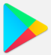Play Store.
2. Tap HOME, GAMES, BOOKS, MOVIES at the left of the Market screen.
• Scroll to view subcategories and tap one to explore.
3. Tap the subcategory you want.

2.Searching for applications
1. From the Home screen, tap Apps > Play Store.
2. Tap at the top right of the screen to search apps.
3. Enter the name or type of app you’re looking for >tap to search.

3.Viewing details about an application
1. While browsing Google Play Store, or in a list of search results, tap an application to view more details.

Application details screens include a description, ratings, and specific information about the application. The Comments tab includes comments from people who have used the application. You can download and install an application from this screen.

2. Installing applications
1.Installing an application
1. From the Home screen, tap Apps > Play Store
2. Find the application you want to purchase and view the application details.
3. Tap Download to download and install the application.
For paid applications, the download button is labeled with the application’s price. Tap the price to buy the application. The subsequent screen notifies you whether the app will require access to your personal information or access to certain functions or settings of your phone.
1. Tap Accept & download to begin downloading and installing the app. If you selected a paid app, you will be redirected to the Google Checkout screen to pay for the app before it’s downloaded to your phone.

NOTE Be cautious when downloading apps that have access to phone functionality or a significant amount of personal data. You’re responsible for the results of using downloaded apps on your phone.

2. Creating a Google Checkout account
You must have a Google Checkout account
to purchase items from Google Play Store.
You can set up a Checkout account with your first purchase from Google Play Store.

• In a web browser, go to http://checkout.google.com to create a Google Checkout account.
• From the phone, you will be prompted to enter your billing and credit card information when you buy your first application from Google Play Store.

NOTE Once you’ve purchased something from Google Play Store, the phone remembers your password, so you don’t need to enter it the next time. Be sure to secure your phone with a password to prevent unauthorized purchases.

3. Managing your downloads
1.Viewing downloaded applications
1. From the Home screen, tap Apps > Play Store
2. Tap Option > My apps & games.
In the list of the free and paid applications that opens, you can tap an application to rate it, uninstall it, request a refund, and more.

2. Updating an application
You can update downloaded applications.
1. From the Home screen, tap Apps > Play Store.
2. Tap Option > My Apps > tap the application to update.
3. Tap Update >Accept & download.
4. Tap the explanation that best matches why you’re installing > tap Open or press Back.
The application is installed. You can uninstall the application again at any time. If you paid to buy the application, you will not be charged again.
3. Uninstalling an application
You can uninstall applications from Google Play Store. You can also uninstall downloaded applications from the Settings.
1. From the Home screen, tap Apps > Settings > Apps.
2. Tap Manage apps >DOWNLOADED > tap the application to uninstall.
3. Tap Uninstall >OK.
4. Tap the explanation that best matches why you’re uninstalling > tap OK.
The application is uninstalled. You can install the application again at any time. If you paid to buy the application, you will not be charged again.

Web

Chrome
Search for information or browse web pages using the Chrome. To access the internet, you must have an active data or Wi-Fi connection.

1. Opening Chrome
1. From the Home screen, tap Apps >Chrome.

• When you open the Browser, the default homepage is displayed. If you have used the Browser recently, your most recently viewed webpage is displayed.
• The Browser also opens when you select a web link in other applications like email or text messaging.

2. Accessing a webpage or searching the web
1. From the Home screen, tap Apps >Chrome.
2. Tap the URL field on top of the screen.
3. Enter the URL of a webpage or search term and tap “Go”.
• As you type, suggestions of web pages and key words will appear on the screen. Tap a suggestion to go directly to that webpage or view search results.

3. Using Browser options
1. Stopping page loading
While webpage is loading, tap on the left of the URL field.

2. the current page
Tap Option >Refresh.

3. Finding the text on the current page
1. While viewing any web pages, tap Option >Find in page.
2. Enter the search term.
• As you type, matching characters will be highlighted. Tap ∧ or ∨ to scroll to the previous or next matching term.

4. Sharing a webpage
1. While viewing any web pages, tap Option >Share ....
2. Tap an application to send the URL. The application opens with the URL you’ve entered.

4. Downloading files

You can download images, files, and applications from web pages. All downloaded files are saved to the microSD card.
1. Tap and hold an image, a link or a file you want to download.
2. Tap the desired action (Save image, View image, or Set as wallpaper).

1. Navigating between webpages
• Press Back to return to the previous web pages.
Or tap Option >Forward if you pressed Back by accident.

2. Switching between Browser windows
1. From any web pages, tap Option >Bookmarks > tap HISTORY .
2. Tap the window to view it full screen. You can also tap to close a window.

NOTE You can have up to 8 browser windows open at one time.

5. Using bookmarks

Browser bookmarks are stored shortcuts which allow you to quickly access webpages without having to type in its full address.

1. Bookmarking a webpage
1. While viewing webpages, tap Option >tap Save to bookmarks.
2. Edit the name or location if needed >tap OK.

2. Opening a bookmark
1. When viewing any webpages, tap Option >Bookmarks.
2. Tap a bookmark to open it.
• If you prefer to open the webpages in a new window, tap and hold the bookmark and tap Open in new tab.

3. Editing a bookmark
1. From any webpages, tap Option >Bookmarks.
2. Tap on the right of the bookmark to edit >Edit.
3. Edit the name and/or location >tap OK.

4. Deleting a bookmark
1. From any webpages, tapOption >Bookmarks.
2. Tap on the right of the bookmark to delete >Delete >OK.

6. Browser settings
Customize your browser settings to optimize your browsing experience.
1. From the Home screen, tap Apps > Browser.
2. Tap Option >Settings.

YouTube Go
YouTube is Google’s online video streaming service
for viewing, discovering, and sharing videos.

1. Opening and signing into YouTube
1. Signing into YouTube
You can discover and watch YouTube videos without a YouTube account, but if you want to take advantage of many YouTube features, you must sign into your YouTube account.
1. From the Home screen, tap Apps > YouTube.
2. Tap Option > Sign in
The first time you use a YouTube feature that requires an account, you’re prompted to sign in. Create a new account or enter your YouTube sign in information if you already have an account. For more information about YouTube accounts, visit YouTube on the web.

2. Finding videos
1. Browsing videos by category
1. From the Home screen, tap Apps >YouTube.
2. Tap YouTube Trending
3. Tap a category in the scrolling list.
• Tap the current time filter setting at the top of the category screen to change the time period and reduce the number of videos listed.
• Tap Most viewed, Top rated, Most discussed or Top favorite.

2. Searching for videos
1. From the Home screen, tap Apps > YouTube.
2. TapSearch.
3. Enter the search criteria >tap to search.
4. Scroll through the search results and tap a video to watch it.

3. Watching videos
1. From the Home screen, tap Apps >YouTube.
2. Tap a video to begin playback.
• Tap the video to pause or resume playback.
• Tap Info, Related videos or Comments to learn more about the video.
• Rotate your phone to watch the video in full-screen view. You can also double-tap the video to toggle full-screen view on and off.

Add to | Watch later | Bookmark the video to watch it later.
 | Favorites | Add the video to your Favorites.
 | New playlist | Add your new playlist.
Share | Share the video via Bluetooth, Email, Gmail

4. Uploading videos
1. To shoot and upload a new video
1. From the Home screen, tap Apps > YouTube.
2. Tap . The Camera will open in video mode.
3. Tap to start recording > tap 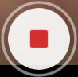to stop recording.
4. Enter a title for the video and more details > tap Upload.

2. To upload an existing video
1. From the Home screen, tap Apps > YouTube.
2. TapOption>Upload. The Gallery will open.
3. Tap the video you want to upload.
4. Enter the title for the video and more details >tap Upload.

5. Sharing videos
1. From the Home screen, tap Apps > YouTube.
2. Tap a video to play.
3. Tap Share.
4. Tap the application you want to use to share the video.

6. YouTube settings

You can change the following settings for YouTube on your phone.
1. From the Home screen, tap Apps > YouTube.
2. Tap Option>Settings.

General settings | High quality on mobile | Check if you prefer to watch videos in high resolution by default when connected to mobile networks. Watch videos in standard mode to reduce startup time and data use. This setting has no effect if you are connected to a Wi-Fi network, where videos are always shown in higher resolution.
 | Caption font size | Set the preferred text size when viewing video captions.
 | Uploads | Specify network preferences for uploads.
Search settings | Clear search history | Remove previous YouTube video search results.
 | SafeSearch filtering | Select if you want Google SafeSearch filtering to block some results when you search for videos. Settings are: Block no search results (Don’t filter), only explicit or offensive videos (Moderate), or both explicit and offensive text and videos (Strict)  .
Preloading | Preload subscriptions | Enable preload to fetch videos in advance while on Wi-Fi and charging, so you can enjoy watching them later on slow networks
 | Preload watch later
About | Help | Open the YouTube Help Center in your phone’s Browser.
 | Feedback | Open a YouTube feedback form in your phone’s Browser.
 | Google Mobile Terms of Service | Display the Google Mobile Terms of Service.
 | YouTube Terms of Service | Display the YouTube Terms of Service.
 | Google Mobile Privacy Policy | Display the Google Mobile Privacy Policy.
 | YouTube Privacy Policy | Display the YouTube Privacy Policy.
 | Application version | The YouTube application version number installed on your phone.

Wi-Fi

1. Turning Wi-Fi on and connecting to a wireless network
1. From the Home screen, tap Apps > Settings.
2. Tap Wireless & Internt >Wi-Fi.
3. Select the Wi-Fi check box to turn Wi-Fi on.
4. The network names and security settings of detected Wi-Fi networks are displayed.
5. Tap a Wi-Fi network to connect.

• If you selected a network that is secured, enter the security key and then tap Connect. Depending on the network type and security settings, you may also need to enter more information or choose a security certificate.

2. Connecting to a Wi-Fi network with EAP-TLS security

You may need to install a network certificate to your phone before you can connect to a Wi-Fi network with EAP-TLS authentication protocol.
1. Save the certificate file to the root folder of the microSD card.
2. From the Home screen, tap Apps > Settings.
3. Tap Security > Encryption& credentials > Install from SD card.
4. Select the network certificate needed to connect to the EAP-TLS network.
5. After the certificate is installed, follow the steps in the previous section to connect to the Wi-Fi network.

3. Checking wireless network status

1. From the Home screen, tap Apps > Settings.
2. Tap Wi-Fi.
3. Tap the wireless network that the phone is currently connected to.

A message box is then displayed showing the Wi-Fi network name, status, speed, signal strength, and more.

4. Connecting to another Wi-Fi network
1. From the Home screen, tap Apps >Settings.
2. Tap Wi-Fi.

Bluetooth

Using Bluetooth
Bluetooth is a short-range wireless communications technology that devices can use to exchange information over a distance of about 30 feet. The most common Bluetooth devices are headphones, hands-free car kits, and portable devices, including laptops and cell phones.

1. Turning Bluetooth on or off
1. From the Home screen, tap Apps > Settings > Connected devices > Bluetooth.
2. Check or uncheck Bluetooth to turn it on or off.

2. Changing the phone’s Bluetooth name
The phone name identifies your phone to other devices.
1. From the Home screen, tap Apps > Settings> Connected devices.
2. Tap Bluetooth.
3. If Bluetooth isn’t turned on, check Bluetooth to turn it on.
4. Tap Device name, enter the name for your phone in the dialog box > RENAME.

3. Pairing your phone with a Bluetooth device
1. From the Home screen, tap Apps > Settings > Connected devices.
2. If Bluetooth isn’t turned on, check Bluetooth to turn it on.
3. Tap Bluetooth > Pair new device. A list of nearby Bluetooth devices is displayed.
4. Tap the ID of the other device to pair them.

4. Connecting to a Bluetooth device

Once paired, your phone will automatically connect whenever it detects a paired Bluetooth device. You can also manually connect Bluetooth devices as follows:
1. From the Home screen, tap Apps > Settings > Connected devices.
2. If Bluetooth isn’t turned on, check Bluetooth to turn it on.
3. Tap Bluetooth > Pair new device.
4. When the phone and the device are connected, the device is displayed as connected in the list.

Disconnecting or Un-pairing from a Bluetooth Device
1. Disconnecting or Un-pairing a Bluetooth device
1. From the Home screen, tap Apps > Settings > Connected devices.
2. Tap Bluetooth.
3. In the paired devices section, tap the on the right side of the device to disconnect.
4. Tap Forget.

Connecting to a Bluetooth Headset
1. From the Home screen, tap Apps > Settings > Connected devices.
2. Tap Bluetooth.
3. If Bluetooth isn’t turned on, check Bluetooth to turn it on.
4. Tap Pair new device. Your phone will start to scan for Bluetooth devices within range.

5. When you see the name of your headset displayed in the Available devices section, tap the name.
Your phone then automatically tries to pair with the Bluetooth device.
6. If automatic pairing fails, enter the passcode supplied with your headset.

1. Reconnecting a headset
1. Put the Bluetooth device in pairing mode.
2. From the Home screen, tap Apps > Settings > Connected devices.
3. Tap Bluetooth.
4. If Bluetooth isn’t turned on, check Bluetooth to turn it on.
5. Tap the device’s name in the Paired devices section.
6. If prompted to enter a passcode, try 0000 or 1234, or consult the headset documentation to find the passcode.

Sending and Receiving Information Using Bluetooth

You can use Bluetooth to transfer information between your phone and another Bluetooth-enabled device such as a phone or laptop computer. You can send the following types of information, depending on the device you are sending to:

• Images and videos

• Contacts

• Audio files

To send files, your phone must have a microSD card installed.

NOTE The first time you transfer information between your phone and another device, you need to enter or confirm a security passcode. Your phone and the other device are then paired, and you will not need to exchange passcodes to transfer information in the future.

1. Sending information from another device
1. On your phone, open the application that contains the item you want to send.
2. Follow the steps for the type of the application, select Share or Send in the menu. Then select Bluetooth.
3. If you are prompted to turn on Bluetooth, tap Turn on.
4. Tap the name of the receiving device.
5. On the receiving device, accept the file.

2. Receiving information from another device

Your device is capable of receiving a wide variety of file types with Bluetooth, including photos, music tracks, and documents such as PDFs.

To receive files from another device, your phone must have a microSD card installed.
1. From the Home screen, tap Apps > Settings > Connected devices.
2. Tap Bluetooth.
3. If Bluetooth isn’t turned on, check Bluetooth to turn it on.
4. Tap the name of the bluetooth to make the device available.
5. On the sending device, send one or more files to your phone.

6. If a Bluetooth authorization request is displayed on your phone, enter the same passcode on both your phone and the other device, or confirm the auto-generated passcode.
7. When your phone receives a file transfer request notification, slide down the notifications panel, and then tap Accept.
8. When the transfer is complete, a notification is displayed. To open the file immediately, slide down the notifications panel, and tap the notification.

Entertainment

Camera/Camcorder
You can take pictures and shoot videos with Camera/Camcorder. Photos and videos captured with the camera will be stored on the internal memory.

1. Opening Camera
• From the Home screen, tap Apps > 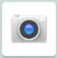 Camera.
• Or, when in Camcorder mode, tap to choose change to camera.

2. Camera settings

When in Camera mode, Camera settings are displayed on screen. Before taking the photo, you can adjust your camera settings or leave the controls in automatic mode.
1. From the Home screen, tap Apps > Camera.
2. Tap Option. The settings open over the screen.

Tap the setting you want to change.

General settings | Exposure | +2, +1, 0, -1, -2
 | Picture size | 2M Pixels, 1.3M Pixels, WXGA, HD720, 1M Pixels, SVGA…
 | Picture quality | Low, Standard, High
 | Countdown timer | Off, 1 second, 2 second, … , 60 seconds
 | Continuous shot | Off, On
GPS location | Off / On | Activate to use your phone’s location-based services. Take pictures wherever you are and tag them with the location.
White balance | Auto, Incandescent, Daylight,  Fluorescent, Cloudy.
Storage | Phone/SD Card | To set the storage location

3. Tap screen to close the settings menus.

3. Taking a picture

1. From the Home screen, tap Apps >Camera.
2. Frame your subject on screen.
• Tap 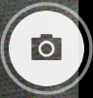 . The camera brings the image into focus. When the image is in focus, the camera takes a picture.
The picture you just took is briefly previewed full-screen, and then is displayed as a thumbnail in the lower left corner. Tap the thumbnail to view, share, or work with your pictures in Gallery.
4. Opening Camcorder
•When you’re in Camera mode, tap to choose change to camcorder.

Camcorder.
1. Camcorder settings

When in Camcorder mode, Camcorder settings are displayed on screen. Before recording, you can adjust your camcorder settings or leave them in automatic mode.
Tap Option. The settings open over the screen.
• Tap screen to close the settings menus
Tap the setting you want to change.

General settings | Flash | On, Off
 | Video quality | HD 720p, SD 480p, CIF, QVGA, QCIF
 | Video duration | 30 seconds (MMS), 10 minutes, 30 minutes, no limit
 | GPS location | On, Off
White balance | Auto, Incandescent, Daylight, Fluorescent, Cloudy.
Storage | To set the storage location to Phone/SD Card

NOTE Depending on the selected video quality, not all video quality and video encoder options may be available.

2. Recording videos
1. From the Home screen, tap Apps > Camera >tap > choose .
2. Frame the scene where you want to start recording.
3. Tap to start recording.
4. Tap 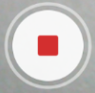 to stop recording.

An image from your most recent video is displayed as a thumbnail at the top right. Tap the thumbnail to view, share, or work with your videos in Gallery.

Sound Recorder
1. Opening Sound Recorder.
1. From the Home screen, tap Apps > Sound Recorder.
2. Tap to start recording a voice clip.
3. Tap to stop recording.
• To save the voice clip, enter voice record name > tap Done.

• To discard the voice clip, tap Discard.

• Tap to listen to the recording.

Tools

Clock
1. Opening the Clock
1. From the Home screen, tap Apps > 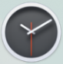 Clock.
• The Clock application opens and displays the date, time and other useful information.
•Tap Alarm to set alarm.

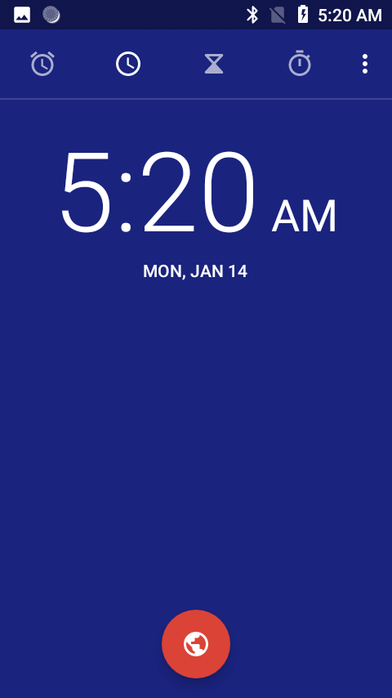

2. Managing Alarms
1. Adding a new alarm
1. From the Home screen, tap Apps > Clock.
2. Tap Alarm> Add alarm.
3. To change the alarm time, scroll up and down to type the number. Then toggle AM/PM >Set.
4. Check the checkbox, ‘Turn alarm on’.
5. Edit Turn alarm on, Time, Repeat, Ringtone, Vibrate and Label > Ok.

2. Editing an alarm
1. From the Home screen, tap Apps > Clock.
2. Tap > Tap an existing alarm.
3. Turn the alarm on or off by checking or un-checking the checkbox, ‘Turn alarm on’. In the alarm list, set alarms are underlined in green.
4. Edit Time, Repeat, Ringtone, Vibrate and Label >Done. Or tap Delete to remove the alarm >OK.

3. Changing alarm settings
1. From the Home screen, tap Apps > Clock
2. Tap > tap Option >Settings.

Silence after | Set how long alarm ring stop.
Alarm volume | Set the volume of alarms.
Snooze length | Set how long Clock waits before playing an alarm again.
Gradually increase volume | Set how long alarm ring gradually increase volume
Volume buttons | Set the side button behavior for alarms.
Start week on | Set week start on Sunday or Saturday or Monday

4. Stopping an alarm
1. When the alarm sounds, tap Dismiss to stop the alarm.

• Tap Snooze to repeat the alarm after a specified length of time.

Calculator
Using Calculator
1. From the Home screen, tap Apps > 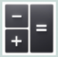Calculator.
2. Enter numbers and arithmetic operators.

• Slide from the panel to left to open Advanced panel.
• Tap and hold the Calculator’s display to open a text editing menu. You can cut, copy, and select text for use in Calculator or other Applications.
• Tap Clear history to delete the last number or operator you entered. Tap and hold DEL to delete everything in the display.

Settings

Settings on Your Phone
Control and customize phone settings on the Settings screen.
1. From the Home screen, tap Apps >Settings.

Network and Internet

Wi-Fi | Wi-Fi On / Off.  Set up and manage Wi-Fi networks. For details about working with these settings, see “Wi-Fi”.
Mobile network | The settings include Roaming, Mobile data, Data usage, network mode, Access Point Names. Also you can select a network operator.
Data usage | This setting you can see mobile data and wi-fi data statistics, and you can turn on or turn off the data.
Hotspot & tethering | The settings include USB tethering, Wi-Fi hotspot and Bluetooth tethering
Mobile plan | Set up mobile plan
VPN | Set up and manage Virtual Private Networks (VPNs).
Airplane mode | Airplane mode On / Off.  Check to turn off all the phone’s radios that transmit voice or data.

Connected devices
Bluetooth | Bluetooth On / Off.  For details about working with these settings, see “Bluetooth”.
Cast | Set to cast screen to nearby devices.
Printing | Add print services to print
USB | Set USB mode

Apps & notifications
Manage apps | Manage and remove installed applications.
Notifications | Manage app notifications for all apps, display on the lock screen, notification dots and default notification sound.
App permissions | Set apps using location, microphone, camera and other permissions.
Default apps | Set default Assist & voice input, Browser app, Home app, Phone app, SMS app
Emergency alerts | Select the types of emergency alerts to display
Special app access | Battery optimization, Device admin apps, Display over other apps…

Battery
Tap Battery you can see how much the apps using the battery and the all battery.

Display

Brightness level | Adjusting the brightness of the screen.
Night Light | Turn on/off Night Light and set schedule
Adaptive brightness | Turn on to optimize brightness level for available light
Wallpaper | You can set wallpaper.
Sleep | Adjust the delay before the screen automatically turns off.
Auto-rotate screen | Automatically switch the orientation of the screen as you turn the phone sideways or even upside down.
Font size | You can set the size of font.
Display size | You can set the size of display.
Screen saver | You can set when to start screen saver
Ambient display | Set whether to wake screen when you receive notifications

Sound
Volume | Set the volume of ringtones that sound when you receive a phone call or notification, media (music, videos, and so on), and alarms.
Also vibrate for calls | Set whether vibrate when calls
Phone ringtone | Select the ringtone to sound when you receive a phone call.
Default notification sound | Select the ringtone to sound when you receive a notification.
Default alarm sound | Select the ringtone to sound when alarm coming.
Dial pad tones | Check to play tones when using dial pad.
Touch sound | Check to play sound when touching the panel.
Charging sound | Check to play sound when connect to charger.
Screen lock sounds | Check to play sounds when locking and unlocking the screen.
Vibrate on tap | When touch the panel will vibrate.
Emergency tone | Select the Emergency tone
Emergency alerts | Select the types of emergency alerts to display

Storage
Storage manager, you can see the SD card and the phone space.

Unmount SD card | Unmout the SD card so you can safely remove it.
Format SD card | Erases all data on the SD card, such as music and photos.
Mount SD card | Add SD card.

Security & Location

Screen lock | Configure your phone to require a pattern, PIN, or password to unlock your screen.
Lock screen preferences | Set to show notification on the lock screen, and message to display on the lock screen.
Location | Turn on/off. And set mode, app-level permissions and scanning and location sevices.
Show passwords | Show password characters as you enter them.
Device admin apps | Manage the admin permission of apps.
Encryption & credentials | Encrypt phone and credential storage settings.
Screen pinning | When turned on, you can use screen pinning to keep the current screen in view until you unpin.

Users & accounts
You can add an account for Duo Preview, Exchange, Google, IMAP and POP3.

Accessibility

Text-to-speech output | When talkback is on, your device provides spoken feedback to help blind and low-vision users. For example, it describes what you touch, select, and activate.
Font size | Make the text on screen smaller or larger.
Display size | Make the item on your screen smaller or larger.
Magnification | Set to magnify with triple-tap and with button
Color correction | Turn on/off. Set color correction mode.
Color inversion | Turn on/off color inversion.
Large mouse pointer | Turn on/off large mouse pointer.
Interaction controls | Include settings about Click after pointer stops moving, Power button ends call, Auto-rotate screen, Touch & hold delay.
Audio & on-screen text | Include Mono audio settings and captions.
Experimental | Turn on/off High contrast text.

Google
You can set google services related settings, such as Ads, Backup, Cast media controls …

System

Language & input | Select the language and keyboard to use for the text on your phone.
Gesture | Set to press the power button twice to jump to camera.
Date & time | Set data, time and the format for displaying date.
Backup | Back up app data, Wi-Fi passwords, and other settings to Google servers.
Reset options | Network, apps, or device can be reset.
About phone | Include system update, status, legal information, Model, Android version, Android security patch level, baseband version, Kernel version, Software version and Hardware version.

System update
- Make sure the target device is power on with a fully charged battery.
- Tap to go to Settings> About phone and tap System update.
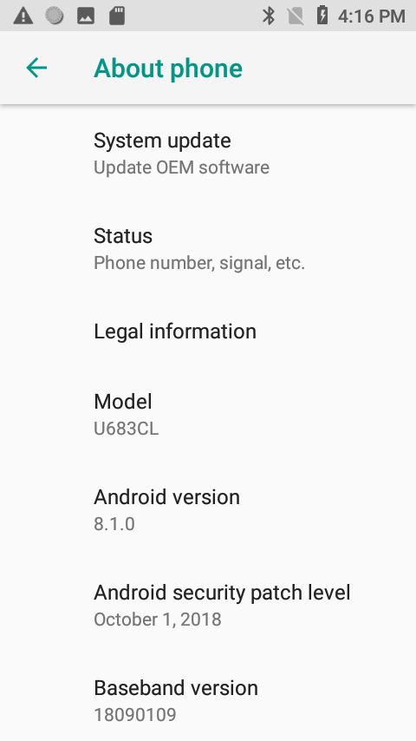

- Upgrade according to tips.

- During the period of update, the target device will automatically reboot for TWO times. Please don’t operate the device until the update is completed.

Google, Android, Google Play and other marks are trademarks of Google LLC.

Safety and use

Please read before proceeding

THE BATTERY IS NOT FULLY CHARGED WHEN YOU TAKE IT OUT OF THE BOX. DO NOT REMOVE THE BATTERY PACK WHEN THE PHONE IS BEING CHARGED. YOUR WARRANTY IS INVALIDATED IF YOU DISASSEMBLE OR ATTEMPT TO DISASSEMBLE THE DEVICE.

1. Privacy restrictions

Some countries require full disclosure of recorded telephone conversations, and stipulate that you must inform the person with whom you are speaking that the conversation is being recorded. Always obey the relevant laws and regulations of your country when using the recording feature of your phone.

2. Disclaimers

ANY WEATHER, STOCK, OR OTHER INFORMATION, DATA, OR DOCUMENTATION (“ACCESSED INFORMATION”) ARE PROVIDED “AS IS” AND WITHOUT ANY WARRANTY OR ANY TECHNICAL SUPPORT. TO THE MAXIMUM EXTENT PERMITTED BY APPLICABLE LAW, UNIMAX COMMUNICATIONS MOBILE AND ITS AFFILIATES expressly disclaim any and all representations and warranties, arising by law or otherwise, related to the Accessed Information, including without limitation any express or implied

representation or warranty of merchantability, fitness for a particular purpose, non-infringement, quality, accuracy, completeness, effectiveness, reliability, or usefulness. Without limiting the foregoing, it is further understood that UNIMAX COMMUNICATIONS Mobile and its Affiliates are not responsible for any use of the Accessed Information or the results arising from such use and that you use such information at your own risk.

Limitation of damages

TO THE MAXIMUM EXTENT PERMITTED BY APPLICABLE LAW, IN NO EVENT SHALL UNIMAX COMMUNICATIONS MOBILE OR ITS AFFILIATES BE LIABLE TO YOU, ANY USER, OR THIRD PARTY FOR ANY INDIRECT, SPECIAL, CONSEQUENTIAL, INCIDENTAL OR PUNITIVE DAMAGES OF ANY KIND, ARISING IN CONTRACT, TORT, OR OTHERWISE, INCLUDING, BUT NOT LIMITED TO, INJURY, LOSS OF REVENUE, LOSS OF GOODWILL, LOSS OF BUSINESS OPPORTUNITY, LOSS OF DATA, AND/OR LOSS OF PROFITS, REGARDLESS OF THE FORESEEABILITYTHEREOF OR WHETHER UNIMAX COMMUNICATIONS MOBILE OR ITS AFFILIATES HAVE BEEN ADVISED OF THE POSSIBILITY OF SUCH DAMAGES. AND IN NO EVENT SHALL THE TOTAL LIABILITY OF UNIMAX COMMUNICATIONS MOBILE OR ITS AFFILIATES EXCEED THE AMOUNT RECEIVED FROM YOU, REGARDLESS OF THE LEGAL THEORY UNDER WHICH THE CAUSE OF ACTION IS BROUGHT. THE FOREGOING DOES NOT AFFECT ANY STATUTORY RIGHTS WHICH MAY NOT BE DISCLAIMED.

Important health information and safety precautions
When using this product, the safety precautions below must be taken to avoid possible legal liabilities and damages. Retain and follow all product safety and operating instructions. Observe all warnings in the operating instructions on the product.
To reduce the risk of bodily injury, electric shock, fire and damage to the equipment, observe the following precautions.

1. Electrical safety

This product is intended for use when supplied with power from the designated battery or power supply unit. Other usage may be dangerous and will invalidate any approval given to this product.
2. Safety precautions for proper grounding installation

Connecting to improperly grounded equipment can result in an electric shock to your device.
This product is equipped with a USB Cable for connecting with desktop or notebook computer. Be sure your computer is properly grounded (earthed) before connecting this product to the computer. The power supply cord of a desktop or notebook computer has an equipment grounding conductor and a grounding plug. The plug must be plugged into an appropriate outlet which is properly installed and grounded in accordance with all local codes and ordinances.

3. Safety precautions for power supply unit
1. Use the correct external power source
A product should be operated only from the type of power source indicated on the electrical ratings label. If you are not sure of the type of power source required, consult your authorized service provider or local power company. For a product that operates from battery power or other sources, refer to the operating instructions that are included with the product.
This product should be operated only with the following designated power supply unit(s).

Travel charge: Input: 100-240V, 50/60Hz,
0.3A Output: 5V, 2000mA
2. Handle battery packs carefully
This product contains a Lithium-ion polymer or Lithium-ion battery. There is a risk of fire and burns if the battery pack is handled improperly. Do not attempt to open or service the battery pack. Do not disassemble, crush, puncture, short external contacts or circuits, dispose of in fire or water, or expose a battery pack to temperatures higher than 140°F (60°C).

Danger of explosion if battery is incorrectly replaced. To reduce risk of fire or burns, do not disassemble, crush, puncture, short external contacts, expose to temperature above 140°F (60°C), or dispose of in fire or water. Replace only with specified batteries. Recycle or dispose of used batteries according to the local regulations or reference guide supplied with your product.

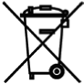

3. Take extra precautions
• Keep the battery or device dry and away from water or any liquid as it may cause a short circuit.

• Keep metal objects away so they don’t come in contact with the battery or its connectors as it may lead to short circuit during operation.

• The phone should only be connected to products that bear the USB-IF logo or have completed the USB-IF compliance program.

• Do not use a battery that appears damaged, deformed, or discolored, or the one that has any rust on its casing, overheats, or emits a foul odor.

• Always keep the battery out of the reach of babies and small children, to avoid swallowing of the battery. Consult the doctor immediately if the battery is swallowed.

• Only use the battery with a charging system that has been qualified with the system per this standard, IEEE-Std-1725-2006. Use of an unqualified battery or charger may present a risk of fire, explosion, leakage or other hazard.

• Replace the battery only with another battery that has been qualified with the system per this standard, IEEE-Std-1725-2006. Use of an unqualified battery may present a risk of fire, explosion, leakage or other hazard.

• Avoid dropping the phone or battery. If the phone or battery is dropped, especially on a hard surface, and the user suspects damage, take it to a service center for inspection.

• If the battery leaks:
• Do not allow the leaking fluid to come in contact with skin or clothing. If already in contact, flush the affected area immediately with clean water and seek medical advice.

• Do not allow the leaking fluid to come in contact with eyes. If already in contact, DO NOT rub; rinse with clean water immediately and seek medical advice.

• Take extra precautions to keep a leaking battery away from fire as there is a danger of ignition or explosion.

4. Safety precautions for direct sunlight

Keep this product away from excessive moisture and extreme temperatures. Do not leave the product or its battery inside a vehicle or in places where the temperature may exceed 140°F (60°C), such as on a car dashboard, window sill, or behind a glass that is exposed to direct sunlight or strong ultraviolet light for extended periods of time. This may damage the product, overheat the battery, or pose a risk to the vehicle.

5. Prevention of hearing loss
Permanent hearing loss may occur if earphones or headphones are used at high volume for prolonged periods of time.

6. Safety in aircraft

Due to the possible interference caused by this product to an aircraft’s navigation system and its communications network, using this device’s phone function on board an airplane is against the law in most countries. If you want to use this device when on board an aircraft, remember to turn off your rf on your phone by switching to Airplane Mode.

7. Environment restrictions

Do not use this product in gas stations, fuel depots, chemical plants or where blasting operations are in progress, or in potentially explosive atmospheres such as fuelling areas, fuel storehouses, below deck on boats, chemical plants, fuel or chemical transfer or storage facilities, and areas where the air contains chemicals or particles, such as grain, dust, or metal powders. Please be aware that sparks in such areas could cause an explosion or fire resulting in bodily injury or even death.
8. Explosive atmospheres

When in any area with a potentially explosive atmosphere or where flammable materials exist, the product should be turned off and the user should obey all signs and instructions. Sparks in such areas could cause an explosion or fire resulting in bodily injury or even death. Users are advised not to use the equipment at refueling points such as service or gas stations, and are reminded of the need to observe restrictions on the use of radio equipment in fuel depots, chemical plants, or where blasting operations are in progress. Areas with a potentially explosive atmosphere are often, but not always, clearly marked. These include fueling areas, below deck on boats, fuel or chemical transfer or storage facilities, and areas where the air contains chemicals or particles, such as grain, dust, or metal powders.

9. Road safety

Full attention must be given to driving at all times in order to reduce the risk of an accident. Using a phone while driving (even with a hands free kit) causes distraction and can lead to an accident. You must comply with local laws and regulations restricting the use of wireless devices while driving.

10. Safety precautions for RF exposure

• Avoid using your phone near metal structures (for example, the steel frame of a building).
• Avoid using your phone near strong electromagnetic sources, such as microwave ovens, sound speakers, TV and radio.
• Use only original manufacturer-approved accessories, or accessories that do not contain any metal.
• Use of non-original manufacturer-approved accessories may violate your local RF exposure guidelines and should be avoided.
11. Interference with medical equipment functions

This product may cause medical equipment to malfunction. The use of this device is forbidden in most hospitals and medical clinics.
If you use any other personal medical device, consult the manufacturer of your device to determine if they are adequately shielded from external RF energy. Your physician may be able to assist you in obtaining this information.
Turn your phone OFF in health care facilities when any regulations posted in these areas instruct you to do so. Hospitals or health care facilities may be using equipment that could be sensitive to external RF energy.

12. Non-ionizing radiation

Your device has an internal antenna. This product should be operated in its normal-use position to ensure the radioactive performance and safety of the interference. As with other mobile radio transmitting equipment, users are advised that for satisfactory operation of the equipment and for the safety of personnel, it is recommended that no part of the human body be allowed to come too close to the antenna during operation of the equipment.
Use only the supplied integral antenna. Use of unauthorized or modified antennas may impair call quality and damage the phone, causing loss of performance and SAR levels exceeding the recommended limits as well as result in non-compliance with local regulatory requirements in your country.
To assure optimal phone performance and ensure human exposure to RF energy is within the guidelines set forth in the relevant standards, always use your device only in its normal-use position. Contact with the antenna area may impair call quality and cause your device to operate at a higher power level than needed. Avoiding contact with the antenna area when the phone is IN USE optimizes the antenna performance and the battery life.

13. Electrical safety
Accessories
• Use only approved accessories.

• Do not connect with incompatible products or accessories.

• Take care not to touch or allow metal objects, such as coins or key rings, to contact or short circuit the battery terminals.

Connection to a car
Seek professional advice when connecting a phone interface to the vehicle electrical system.

Faulty and damaged products
• Do not attempt to disassemble the phone or its accessory.

• Only qualified personnel must service or repair the phone or its accessory.

14. General precautions

You alone are responsible for how you use your phone and any consequences of its use. You must always switch off your phone wherever the use of a phone is prohibited. Use of your phone is subject to safety measures designed to protect users and their environment.
Avoid applying excessive pressure to the device
Do not apply excessive pressure on the screen and the device to prevent damaging them and remove the device from your pants’ pocket before sitting down. It is also recommended that you store the device in a protective case and only use the device stylus or your finger when interacting with the touch screen. Cracked display screens due to improper handling are not covered by the warranty.
Device getting warm after prolonged use
When using your device for prolonged periods of time, such as when you’re talking on the phone, charging the battery or browsing the Web, the device may become warm. In most cases, this condition is normal and therefore should not be interpreted as a problem with the device.
Heed service markings
Except as explained elsewhere in the Operating or Service documentation, do not service any product yourself. Service needed on components inside the device should be done by an authorized service technician or provider.
Protect your phone
• Always treat your phone and its accessories with care and keep them in a clean and dust-free place.

• Do not expose your phone or its accessories to open flames or lit tobacco products.

• Do not expose your phone or its accessories to liquid, moisture or high humidity.

• Do not drop, throw or try to bend your phone or its accessories.

• Do not use harsh chemicals, cleaning solvents, or aerosols to clean the device or its accessories.

• Do not paint your phone or its accessories.

• Do not attempt to disassemble your phone or its accessories, only authorized personnel must do so.

• Do not expose your phone or its accessories to extreme temperatures, minimum -4°F (-20°C) and maximum 122°F (50°C).

• Please check local regulations for disposal of electronic products.

• Do not carry your phone in your back pocket as it could break when you sit down. Damage requiring service
Unplug the product from the electrical outlet and refer servicing to an authorized service technician or provider under the following conditions:

• Liquid has been spilled or an object has fallen into the product.

• The product has been exposed to rain or water.

• The product has been dropped or damaged.

• There are noticeable signs of overheating.

• The product does not operate normally when you follow the operating instructions.
Avoid hot areas
The product should be placed away from heat sources such as radiators, heat registers, stoves, or other products (including amplifiers) that produce heat.
Avoid wet areas
Never use the product in a wet location.
Avoid using your device after a dramatic change in temperature
When you move your device between environments with very different temperature and/or humidity ranges, condensation may form on or within the device. To avoid damaging the device, allow sufficient time for the moisture to evaporate before using the device.
NOTICE: When taking the device from low-temperature conditions into a warmer environment or from high-temperature conditions into a cooler environment, allow the device to acclimate to room temperature before turning on power.
Avoid pushing objects into product
Never push objects of any kind into cabinet slots or other openings in the product. Slots and openings are provided for ventilation. These openings must not be blocked or covered.
Air bags
Do not place a phone in the area over an air bag or in the air bag deployment area. Store the phone safely before driving your vehicle.
Mounting accessories
Do not use the product on an unstable table, cart, stand, tripod, or bracket. Any mounting of the product should follow the manufacturer’s instructions, and should use a mounting accessory recommended by the manufacturer.
Avoid unstable mounting
Do not place the product with an unstable base.
Use product with approved equipment
This product should be used only with personal computers and options identified as suitable for use with your equipment.
Adjust the volume
Turn down the volume before using headphones or other audio devices. Cleaning
Unplug the product from the wall outlet before cleaning. Do not use liquid cleaners or aerosol cleaners. Use a damp cloth for cleaning, but NEVER use water to clean the LCD screen. Small children
Do not leave your phone and its accessories within the reach of small children or allow them to play with it. They could hurt themselves or others, or could accidentally damage the phone. Your phone contains small parts with sharp edges that may cause an injury or which could become detached and create a choking hazard.
Repetitive motion injuries
To minimize the risk of RSI, when Texting or playing games with your phone:

• Do not grip the phone too tightly

• Press the buttons lightly

• Make use of the special features in the handset which minimize the number of buttons which have to be pressed, such as message templates and predictive text.

• Take lots of breaks to stretch and relax.
Operating machinery
Full attention must be given to operating the machinery in order to reduce the risk of an accident.
Loud noise
This phone is capable of producing loud noises which may damage your hearing.
Emergency calls
This phone, like any wireless phone, operates using radio signals, which cannot guarantee connection in all conditions. Therefore, you must never rely solely on any wireless phone for emergency communications.

Regulatory agency identifications

1. FCC Regulations:
This mobile phone complies with part 15 of the FCC Rules. Operation is subject to the following two conditions: (1) This device may not cause harmful interference, and (2) this device must accept any interference received, including interference that may cause undesired operation.
This mobile phone has been tested and found to comply with the limits for a Class B digital device, pursuant to Part 15 of the FCC Rules. These limits are designed to provide reasonable protection against harmful interference in a residential installation. This equipment generates, uses and can radiated radio frequency energy and, if not installed and used in accordance with the instructions, may cause harmful interference to radio communications. However, there is no guarantee that interference will not occur in a particular installation If this equipment does cause harmful interference to radio or television reception, which can be determined by turning the equipment off and on, the user is encouraged to try to correct the interference by one or more of the following measures：
-Reorient or relocate the receiving antenna.
-Increase the separation between the equipment and receiver.
-Connect the equipment into an outlet on a circuit different from that to which the receiver is connected.
-Consult the dealer or an experienced radio/TV technician for help.
Changes or modifications not expressly approved by the party responsible for compliance could void the user‘s authority to operate the equipment.
2. RF Exposure Information (SAR)
This mobile phone meets the government’s requirements for exposure to radio waves.
This phone is designed and manufactured not to exceed the emission limits for exposure to radio frequency (RF) energy set by the Federal Communications Commission of the U.S. Government.
The exposure standard for wireless mobile phones employs a unit of measurement known as the Specific Absorption Rate, or SAR. The SAR limit set by the FCC is 1.6W/kg. *Tests for SAR are conducted using standard operating positions accepted by the FCC with the phone transmitting at its highest certified power level in all tested frequency bands. Although the SAR is determined at the highest certified power level, the actual SAR level of the phone while operating can be well below the maximum value. This is because the phone is designed to operate at multiple power levels so as to use only the power required to reach the network. In general, the closer you are to a wireless base station, the lower the power output.
The highest SAR value for the model phone as reported to the FCC when tested for use at the ear is 1.18 W/kg and when worn on the body, as described in this user guide, is 1.08 W/kg (Body-worn measurements differ among phone models, depending upon available accessories and FCC requirements.)
While there may be differences between the SAR levels of various phones and at various positions, they all meet the government requirement.
The FCC has granted an Equipment Authorization for this model phone with all reported SAR levels evaluated as in compliance with the FCC RF exposure guidelines. SAR
information on this model phone is on file with the FCC and can be found under the Display Grant section of www.fcc.gov/oet/ea/fccid after searching on FCC ID: P46-U683CL.
For body worn operation, this phone has been tested and meets the FCC RF exposure guidelines for use with an accessory that contains no metal and the positions the handset a minimum of 1.5 cm from the body. Use of other accessories may not ensure compliance with FCC RF exposure guidelines. If you do no t use a body-worn accessory and are not holding the phone at the ear, position the handset a minimum of 1.5 cm from your body when the phone is switched on.

HEARING AID COMPATIBILITY HAC FOR WIRELESS TELECOMMUNICATIONS DEVICES

THIS PHONE HAS A HAC RATING OF M4/T3
WHAT IS HEARING AID COMPATIBILITY?
The Federal Communications Commission has implemented rules and a rating system designed to enable people who wear hearing aids to more effectively use these wireless telecommunications devices. The standard for compatibility of digital wireless phones with hearing aids is set forth in American National Standard Institute (ANSI) standard C63.19. There are two sets of ANSI standards with ratings from one to four (four being the best rating): an “M” rating for reduced interference making it easier to hear conversations on the phone when using the hearing aid microphone, and a “T” rating that enables the phone to be used with hearing aids operating in the tele-coil mode thus reducing unwanted background noise.

HOW WILL I KNOW WHICH WIRELESS PHONES ARE HEARING AID COMPATIBLE?
The Hearing Aid Compatibility rating is displayed on the wireless phone box.
A phone is considered Hearing Aid Compatible for acoustic coupling (microphone mode) if it has an “M3” or “M4” rating. A digital wireless phone is considered Hearing Aid Compatible for inductive coupling (tele-coil mode) if it has a “T3” or “T4” rating.
HOW WILL I KNOW IF MY HEARING AID WILL WORK WITH A PARTICULAR DIGITAL WIRELESS PHONE?
You’ll want to try a number of wireless phones so that you can decide which works the best with your hearing aids. You may also want to talk with your hearing aid professional about the extent to which your hearing aids are immune to interference, if they have wireless phone shielding, and whether your hearing aid has a HAC ratio

